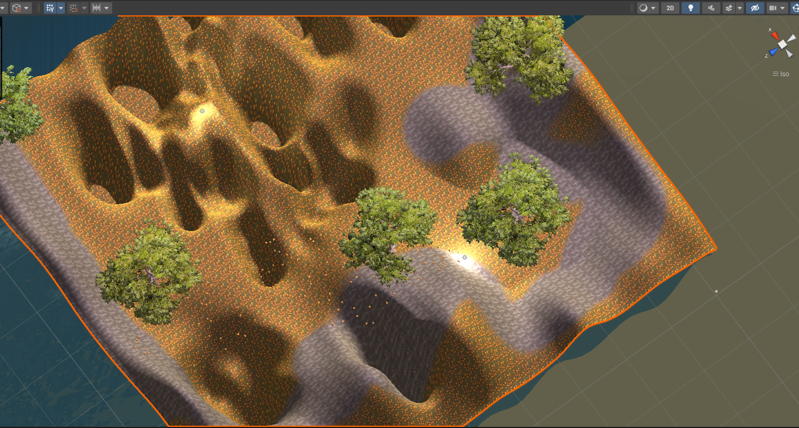
2 finish zones.
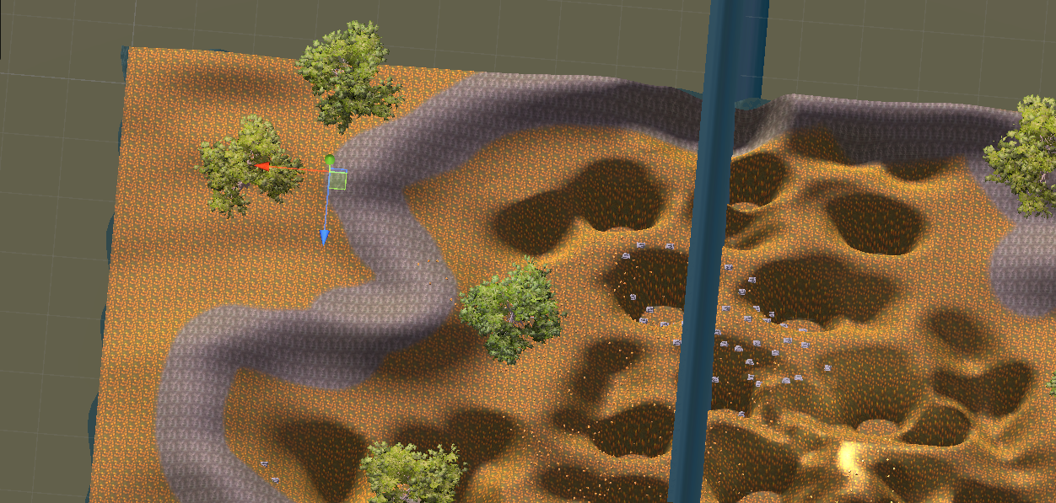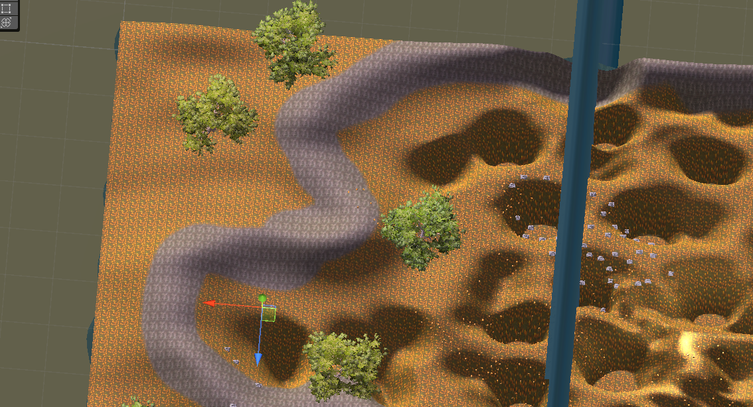
2 spawn points.

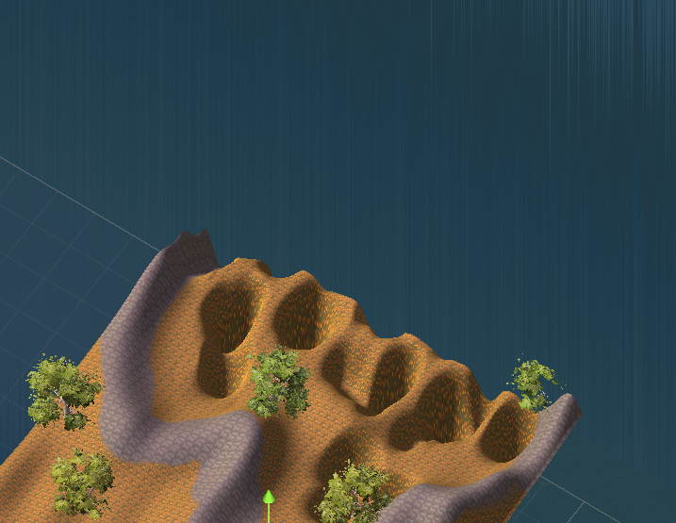
The waterfall barrier changes your spawn point.
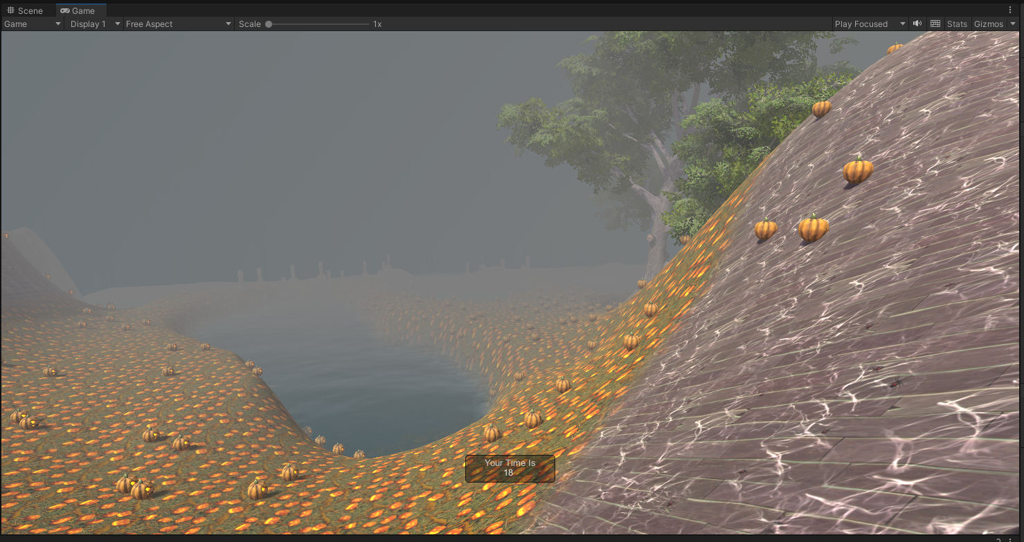
In game - heavy fog to change the sky.

a. Game Mechanics
The core mechanics of my Amazing Racer Mod revolve around movement and risk-based path selection. The player controls a first-person character that starts the race at a designated spawn point. A timer begins once the player starts moving and ends when the player reaches one of multiple finish zones. Water hazards reset the player to their current or designated spawn point. A checkpoint placed at Spawn B shifts the player’s respawn location mid-race, making the second half of the course more punishing if they fail. There are two finish zones that give the player a choice between a longer, safer route or a shorter, riskier route. Fog limits visibility, increasing the need for quick decisions and careful movement. Mechanics emphasize challenge, choice, and consequences.
b. Game Aesthetics
The visual environment is designed to create a foggy Halloween atmosphere. The terrain uses autumn-themed colors with orange ground textures, rocky cliffs, and dark reflective water. Fog reduces visibility, adding a sense of unease and tension as players move through narrow paths. The checkpoint cube is made partially transparent, so it is visible but does not interfere with the environment. The aesthetic design communicates a haunted forest feel, combining low lighting, fog, and natural elements to build mood and atmosphere.
c. Game Narrative
The narrative is implied through the environment rather than delivered through dialogue or text. The player is racing through a haunted forest as the fog grows heavier, symbolizing danger and urgency. The two different paths represent choice and risk: the safe route reflects caution while the punishing route represents boldness and speed with greater consequences for mistakes. The fog and the terrain tell the story without explicitly stating it, reinforcing the theme through environmental design.
d. Game Technology
The game is built in Unity using the First Person Controller from the Standard Assets package. Terrain Tools were used to sculpt steep cliffs, narrow pathways, and water features. Water (Basic) assets are used for the hazard zones. Custom C# scripts control the main systems: GameManager handles the timer and overall flow of the race, PlayerRespawn manages the hazard respawns, Checkpoint allows for changing the active spawn point, and FinishZone ends the race when the player reaches a finish area. Fog is configured through the lighting settings, and transparent materials are applied to the checkpoint for visual clarity. These technologies combine to support the mechanics, aesthetics, and narrative of the game.
a. Lens 20: The Lens of Pleasure
The primary pleasure in this game comes from movement, risk-taking, and mastery. Players experience sensory pleasure through the foggy Halloween environment, the narrow pathways, and the feeling of navigating a dangerous terrain. The fog and lighting give the level a strong atmosphere, which heightens emotional engagement. There is also pleasure in accomplishment when players make it through difficult terrain or choose the punishing path and succeed. One area that could be improved is variety in movement feedback or rewards at finish points. For example, adding subtle sound effects, animations, or on-screen effects when reaching checkpoints or finishes would increase the satisfaction of progress. The game currently lacks strong social or discovery pleasures, as it focuses primarily on single-player racing and risk navigation.
b. Lens 21: The Lens of Flow
The game has clear goals. The player starts at a spawn point, avoids hazards, passes checkpoints, and finishes at one of two finish zones. The fog slightly limits visibility but does not distract from the goal, instead making it more challenging and immersive. The difficulty curve fits the flow state because the first part of the race is simpler, allowing players to get used to movement, while the second half with the punishing Spawn B raises the stakes. The challenge level is not so high that it frustrates the player, but not too easy to make the experience dull. Flow is maintained through a balance of risk and reward. Improvement could come from fine-tuning checkpoint placement or adding optional obstacles for skilled players to maintain engagement over multiple runs.
c. Lens 22: The Lens of Needs
This game operates mainly on the levels of safety and competence in Maslow’s hierarchy. The player experiences a sense of urgency due to the foggy, dark environment and water hazards, creating an instinct to reach the finish. It also fulfills the need for competence as players must master movement, terrain reading, and risk assessment. Autonomy is present in the choice between multiple finish zones, allowing players to control their strategy. Relatedness is not a core part of the experience since the game is currently single-player, but it could be added with leaderboards or cooperative/competitive modes. The needs already being fulfilled could be improved by adding more feedback to make progress feel more meaningful, and optional side challenges to give players additional ways to demonstrate mastery

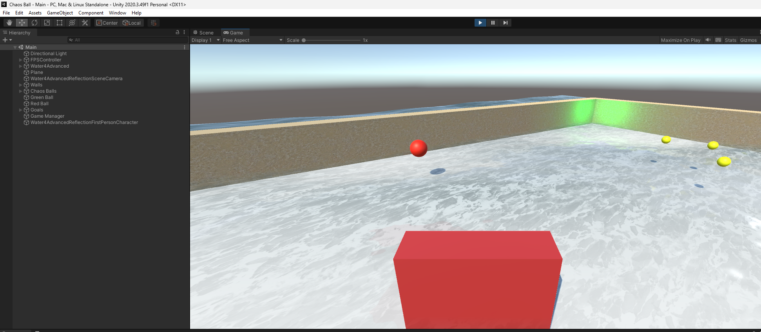
- As I played the base version of Chaos Balls, I found that the game is moderately easy once I understood the physics. The four colored balls move at a steady speed, and the chaos balls provide a small amount of disruption, but not enough to feel overwhelming. Increasing the speed of the chaos balls would make the game more difficult. Adding more of them could also create a higher level of pressure and unpredictability. To give the game a “wow” factor, I would add dynamic lighting effects or sound feedback when the player successfully places a ball in the correct corner. The fun part of the game is the physics interaction, watching balls bounce around and trying to time my movement. The tedious part is the lack of variety in ball behavior and the slow pace after several bounces.
- I would change several elements of the game to increase engagement and challenge. First, I would add a replay button so players can easily restart once they complete the objective. Second, I would add a timer to make the game more competitive and give players a clear performance metric. Third, I would vary the chaos balls, giving some different speeds or bounce characteristics to increase unpredictability. Fourth, I would change the size of the player’s bumper to make the game feel more dynamic, possibly with a slightly curved surface to influence ball direction more dramatically. Finally, I would modify the audio so that movement and collisions feel more appropriate to the theme. My chosen theme would be a nighttime arena with a glowing, neon aesthetic, where the colored balls stand out vividly against a dark background. This would make the game feel more energetic and visually striking.

